The Route to the Magical Fizzy Lifting Gas

To start things off, it is somewhat unclear where the expedition should start. On one hand it would make sense to lay down in Olyntheos, the capital of Basilia and by far the most developed city after Markarska (which, because its a giant city, does not allow airships anywhere close to it).

On the other hand, it might also make sense to touch down in either Vebeira or Varevento, since they are physically closer to the death zone and likely more closely aligned with the Association. This would make for a longer trip though.

Descriptions of all these places are included in Idrasia.doc. Obviously everything here and in that document can be changed at DM's discretion. Perhaps things have changed in recent years!

I'm going to assume Olyntheos for now. It might make sense to go on the following route:

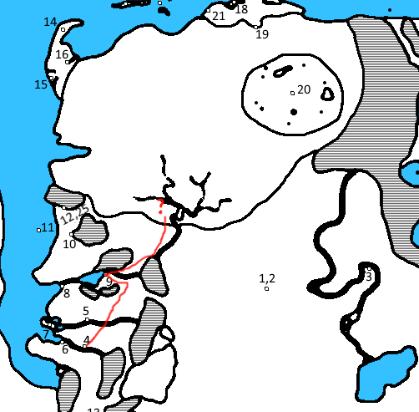

Considerations about Olyntheos
-It is likely merchant families have locations here
-It is possible to buy almost everything here
-Getting into the city itself is expensive. How would we deal with that? Perhaps the airship landing is outside the city center.
-The Association is looked down on here.
-The city has a fairly large and well supplied guard contingent (Think minas tirith type armor)

Possible interesting encounters
-Meeting or seeing an undead investigator
-The undying king ventures out to give a speech for some reason
-Ambassadors from another nation
-Dragonkin!
-Some kind of rabble rousing from the death clerics/aristocracy
-Encounter with the The Faceless Artist

From Olyntheos, it might make sense to go to the death zone via Crucible

The road to Crucible is probably pretty boring, and might actually be actively guarded. The land is rolling countryside with increasing hills until Crucible.

Considerations about Crucible
-The city is based on art, magic and madness
-The entire place is anarchy. You could be stolen from, proposed to, assaulted, asked to pose for a painting all in the same morning.
-The madness is catching. If you stay too long you will get it also. Maybe at some point you might actually want it :))))

Possible Interesting Encounters
-Some sort of interaction with the The Pale Lady
-Temposanire
-Encounter with the The Faceless Artist
-Proposition to engage in some sort of art or magical ritual
-A lesser circle prince trying to study the city
-A former member of another nation who has gone native. May be interesting to have them be a former Association agent or Grey Mage.
-The city simply isn't there when we arrive (*laughs in DM*)
-We somehow find the portal the Grey Mages have built on its outskirts

The land after Crucible is much less traveled. It becomes more and more forested until the pass. Encounters with wild animals are likely. There is a bit of a road, but its likely dirt.

After the pass, the land is loosely controlled by giant aligned plainsmen. They may or may not be hostile. Maybe we have to help them with something in order to pass. Encounters with wild plains animals are common. There is no road.

After that is the actual death zone. The exact location in which the gas appears is ambiguous. It might make sense to have it connected in some way with the river which flows into that land. I imagine the gass as seeming from some noxious fumarole, but that’s just me.

Death Zone
Possible Interesting Encounters
-Land giving away into sinkholes
-Attacked by undead, abominations or both
-Find a misplaced Khanate wanderer or teleportation failure Grey Mage (poor guy)
-Encounter with Tymnozavod
-Encounter with a lesser prince
-Encounter with an expedition into the death zone, probably either by the plainsmen or Basilia

